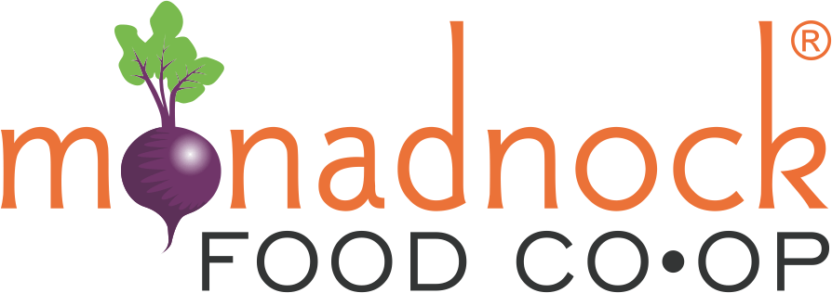
2023 Farm Fund
Application

Project Title:

Amount Requested: , Match Provided: , Total Budget:

Project Location:

Contact Information

Contact Person:

Mailing Address: Town: State: Zip:

Phone Number:

Email:

Applicant Information

Business or Organization Name:

Website:

Year your business started:

Do you have a business plan? If yes, please submit as an attachment. Grant scoring criteria includes a review of your business plan.

Briefly describe your product(s) or service(s):

Official tax structure of your organization: (e.g. LLC, 501c3, etc)

Briefly describe your management team, including key board members, advisers, and staff and their roles:

Project Description
(Please answer the following questions (#1-10) in 1,000-1,500 words total in this question format. Please do not use a separate narrative)

- Please describe your project?

- What is the need or opportunity this project will address?

- What are the project’s goals?

- What are the tasks and timeline of the project?

- Please describe your current wholesale product distribution and what percentage of total farm sales they make up.

- How will this project improve your farm’s ability to increase sustainable wholesale food production and/or improve the viability of your farm business?

- Please describe the capacity of your farm to complete the project? Who will be responsible? Please use names and relevant experience where applicable.

- Will you be willing to work with the MFC and CCCD to make the public aware of the project (e.g. press, community events, host a farm tour, etc.) ? Please explain your level of interest?

- How will you educate other farmers on the benefit of the project?

- What is your plan for covering ongoing costs after the grant is completed (e.g. equipment maintenance)?

- How/when will you know you’re successful? What metrics and targets will you use?

- Are there any broader benefits to the community that the project offers?

Project Budget

Amount Requested ($500 - $20,000):

How much money is needed in total to complete the proposed project?

If your group receives a Monadnock Food Co-op Farm Fund grant, how do you plan to pay for remaining expenses? Please explain the source and status of the other funds (e.g. are they secured?)

Please summarize your project costs in the table below. Include any costs covered by the farm applicant, costs requested from the grant fund, and funds contributed from other sources. Check the corresponding box to indicate which expenses the applicant will cover (e.g. farm labor), which expenses will be covered by other sources (if any), which expenses you request from the grant fund.

Allowable expenses: equipment, installation by qualified contractors, professional services
Expenses not allowed: farm staff hours, no more than 20% of the budget can be consumable items (e.g. packaging, labels, etc.)
Budget Item |  |  |  | Total Amount |  | Grant Request | Applicant Costs | Other
Labor ( 40 hours @ $30/hour) |  |  |  | $ |  |  | $
Supplies |  |  |  | $0.00 |  | $6,000
Contractors |  |  |  | $0.00 |  | $4,000
 |  |  |  | $0.00
 |  |  |  | $0.00
 |  |  |  | $0.00
 |  |  |  | $0.00
 |  |  |  | $0.00
TOTAL EXPENSES |  |  |  | 13000 |  | 10,000 | 3000

Please provide a budget justification narrative:

Further questions and/or references may be requested upon committee review.

Thank you!
By submitting this application, if approved, you give permission to announce the grant award through area media sources and publicize your organization as a recipient of a Monadnock Food Co-op Farm Fund Grant in promotional material.
Grants are expected to be used for their stated purpose by the end of the calendar year; if necessary, grantee may request an extension of the grant period or return unused funds.
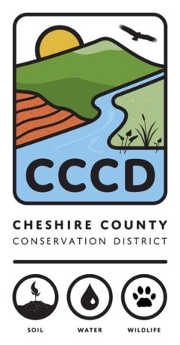
---------------------------------------------------------------------------------------------------------------------------------------
For further information contact: Amanda Littleton at (603) 756-2988 ext.4 or amanda@cheshireconservation.org
The Cheshire County Conservation District is a management partner and fiscal sponsor of the Monadnock Food Co-op Farm Fund. The Cheshire County Conservation District’s mission is to promote the conservation and responsible use of our natural and agricultural resources for the people of Cheshire County by providing technical, financial, and educational assistance.
Our goal is to encourage the stewardship of healthy soils, productive ecologically sound farms, diverse wildlife, productive sustainable forests, healthy watersheds, and clean water to ensure those resources are available for future generations.

