Project name:
Applicant:
Acres:
Amount Requested: | $

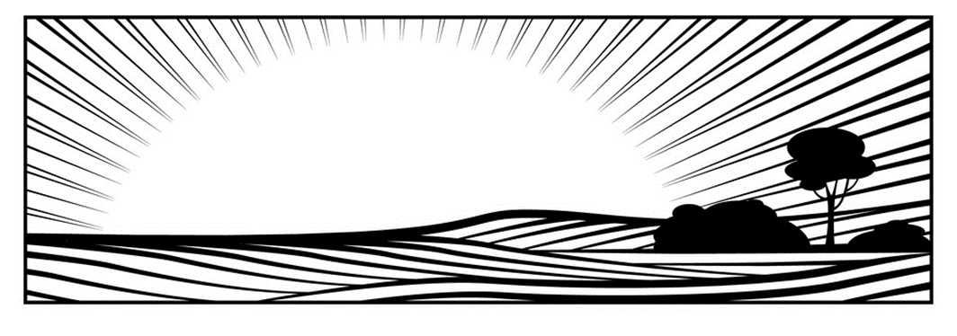
2024
NH Farm
Future Fund

Application Form

Before completing this application, please carefully review the Request for Proposals (RFP), which is available at https://www.cheshireconservation.org/nhfff

Only submit an application if you check YES to all of the following criteria

Primary Criteria | NO | YES
You are a qualified applicant – a nonprofit tax exempt 501(c)(3) organization that has land conservation as a primary function
The project permanently protects farmland in New Hampshire through acquisition of fee interest and/or a permanent conservation easement
The project will be completed and all grant funds spent within 1.5 years from the date of the grant award. Extensions will be available upon request and approval.

There has been a Discovery Meeting held with the land trust representative, Farm Partner, NH Community Loan Fund advisor, and Land For Good.
There is a strong stated commitment from the project’s Farm Partner to keep the land in agricultural production and to engage with and seek meaningful results from the technical assistance that will be provided. This commitment must be in writing in a Farm Partner Letter as part of the application package.

You, as the applicant, have demonstrated capacity and financial ability to execute the transaction and ensure perpetual stewardship of the protected property.

You have secured a minimum 25% cash match, or have plans to secure it during the project timeframe. The cash match must be outlined in the project budget.

Applicant Information
Date of Application:
Applicant Name:
Applicant Mailing Address:

Contact Person:
Phone:
Email:
Applicant Tax ID# (required) | #
Project Information
Project Name: -
Town:
Total Acres to be Conserved:
Of total conserved acres, acres in open farmland:
Of total conserved acres, acres in forestland:
Total Project Budget:
Grant Amount Requested:
Project Summary:
(100 words max.)
Must include the following:
- Protection mechanism (fee/easement) and if donated, full purchase, bargain sale, etc.
-- Proposed uses of NH Farm Future funds (Technical and Financial assistance)

Project Narrative – 1,000 word maximum

The narrative must address the following items. Please answer questions directly and in order below.

- Briefly describe the natural assets that make this property a priority for protection (e.g. soils, open acres). Also, please explain the type and degree of conversion threat to the farmland proposed for conservation.

- What are the agricultural assets of the property? Please consider housing, infrastructure, access to water, and proximity to supply chain infrastructure and markets.

- How will the project permanently protect the land being proposed for conservation?

acquisition of fee interest permanent conservation easement

- Do you have a signed purchase and sales agreement for the land being proposed for conservation?

Yes

No

(if no please provide the date at which you anticipate having a signed purchase and sales agreement) Date:____________________

- Who is the Farm Partner and what is their level of commitment to receiving technical assistance through this project?
The Farm Partner is the farmer/landowner of the agricultural resource who has agreed to partner with the land trust to conserve the land and strive to keep it productive and profitable. The Farm Partner is required to be engaged and interested in participating in farm viability and/or land transfer planning. The Farm Partner will work with the land trust, LFG, and the NHCLF to define their interests, goals, and desired outcomes in the application for funding. The answer to this question will be informed by the Discovery Meeting that is required in advance of completing the application.

- (Please answer #6 or #7 as applicable to the situation) If the Farm Partner currently has an agricultural business on the land proposed for protection please summarize that business. Please also provide information on current profitability (sales, net income, assets and liabilities) and challenges to future profitability.

- If the Farm Partner does not currently have an existing agricultural business, please describe the plan for future agricultural uses, and the Farm Partner’s qualifications to run a farm business (e.g. management and agricultural skills and experience). Are there agricultural operations/practices that would not be acceptable?

- What is the project timeline, including when NH Farm Future grant funds would be required?

- Is the applicant accredited by the Land Trust Alliance? If yes, please skip question #10.

Yes No

- Describe the applicant’s capacity and financial ability to execute the proposed conservation transaction and ensure perpetual stewardship of the protected property Please provide the following information: acres you currently oversee, amount of stewardship endowment.

Project Financial Summary – Overall Conservation Project

Sources of Funds – please list each source and the corresponding dollar amount
Public funding (municipal, state, federal) | $
Private funding (foundations, corp., individuals) | $
Landowner donation of land value (please note source of estimated value: appraisal, town assessment, etc.) | $
Other donated (in kind services, etc.) | $
NH Farm Future grant request (cannot be more than 75 % of budget. Maximum request of $20,000) | $
Total Sources of Funds | $

Budget Table and Budget Justification Narrative - NH Farm Future Fund Workplan:

Please insert a budget table in the space below that identifies line items of expenses for the NH Farm Future Fund. Please provide detail on expenses for financial assistance to the land trust (financial assistance to the land trust as identified in the RFP is a maximum of 50% of funds requested). For technical assistance you can state the total amount requested in the budget. The details will be determined by the farm partner and technical service providers if funding is awarded. The total budget request can not exceed $20,000.

(INSERT BUDGET TABLE HERE)

The budget justification narrative should explain in detail the line items in the budget table. Please provide narrative here:

Project Mapping

All applicants are required to submit with their application a Geographic Information System (GIS) “shapefile” showing the property boundaries of the proposed project. The shapefile will be used for internal mapping purposes.

RE: delivery of GIS data—please include the following field in the attribute table for each parcel of your shapefile:

Tract Name (fill in the name of the tract please) (Make sure the Properties of this field is a Text field with a length of 40 characters.)

Submission

Applicants should submit the following items in support of their application:

- Project Application – including narrative and financial information
- Farm Partner Letter – This is a letter written by the Farm Partner that expresses their interest in and commitment to seeking technical assistance. This will be informed by the Discovery Meeting that is required before submitting the application. The readiness of Farm Partners to receive technical assistance is a key factor of success for this project.
- Farm Partner Questionnaire – final pages of the application to be completed by Farm Partner.
- Financials of existing farm businesses or farm business plan as applicable (per #6-7 above)
- Project maps—One topo and one aerial map (jpgs)
- Photos—One or two photos of the property (jpgs)
- GIS Shapefile

Completed applications must be received no later than 5 p.m. on May 31, 2024. Completed applications may be submitted electronically to amanda@cheshireconservation.org . All grant applicants will be notified of selection results by July 15, 2023.

Further questions and/or references may be requested upon committee review.

By submitting this application, if approved, you give the Cheshire County Conservation District and New Hampshire Conservation Districts permission to announce the grant award through area media sources and publicize your organization as a recipient of a NH Farm Future Fund grant in promotional material. Access to the application and supporting materials will be provided to the review committee and program partners.

Farm Partner Questionnaire
The following to be completed by the Farm Partner and submitted with their letter as part of the application.

Farmer Information
Farm Name:
Farmer Name:
Farm Website:
Farm Social Media:
Farm Mailing Address:

Phone:
Email:
Preferred Method of Communication (Text, Phone, Email, Facebook Messenger, Other):

Please check Yes or No for each category to indicate if you are interested in receiving technical assistance. If Yes, please indicate level of need/interest on the following line in each category.

Technical Assistance Needs and Interest | Yes | No
Estate Planning

Low Need/Interest | Medium Need/Interest | High Need/Interest
Business Planning

Low Need/Interest | Medium Need/Interest | High Need/Interest
Technical Assistance Needs and Interest  (Please Check Yes or No and indicate level of interest) | Yes | No
Enterprise Analysis

Low Need/Interest | Medium Need/Interest | High Need/Interest
Marketing Strategy

Low Need/Interest | Medium Need/Interest | High Need/Interest
Communications Planning

Low Need/Interest | Medium Need/Interest | High Need/Interest
Employee Management

Low Need/Interest | Medium Need/Interest | High Need/Interest
Management Transfer Planning

Low Need/Interest | Medium Need/Interest | High Need/Interest
Succession Planning

Low Need/Interest | Medium Need/Interest | High Need/Interest
Conservation Easement Legal Review

Low Need/Interest | Medium Need/Interest | High Need/Interest
Land Base/ Conservation Assessment & Planning (forage species, soil fertility, water resources, livestock carrying capacity)

Low Need/Interest | Medium Need/Interest | High Need/Interest
Process Efficiencies

Low Need/Interest | Medium Need/Interest | High Need/Interest
Business Structure

Low Need/Interest | Medium Need/Interest | High Need/Interest
Sales strategy

Low Need/Interest | Medium Need/Interest | High Need/Interest
Climate Mitigation Planning

Low Need/Interest | Medium Need/Interest | High Need/Interest
Forest Management Plan

Low Need/Interest | Medium Need/Interest | High Need/Interest
Legal Services For (please share below):

Low Need/Interest | Medium Need/Interest | High Need/Interest
Other (please share below):

Low Need/Interest | Medium Need/Interest | High Need/Interest

