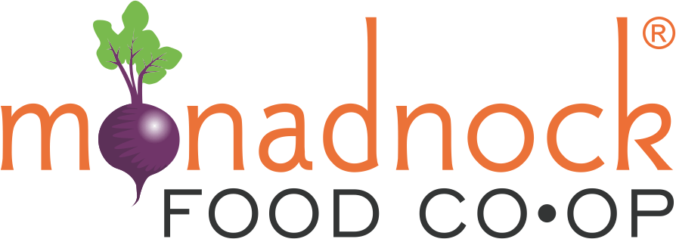
2024 Farm Fund
Application for
Emergency Relief

Amount Requested:

Contact Information

Contact Person:

Mailing Address: Town: State: Zip:

Phone Number:

Email:

Applicant Information

Business or Organization Name:

Website:

Year your business started:

Do you have a business plan? If yes, please submit as an attachment.

Briefly describe your product(s) or service(s):

Official tax structure of your organization: (e.g. LLC, 501c3, etc)

Briefly describe your management team, including key board members, advisers, and staff and their roles:

Emergency Relief Request
(Please answer the following questions in 1,000-1,500 words total in this question format. Please do not use a separate narrative)

- Please provide a summary of your crop/livestock loss:

- Please define quantity (e.g. acres, head) and value of loss:

- Please provide a summary of other business and/or personal property loss:

- Please define the value your business and/or personal property loss:

- What impact will this loss have on your farm’s profitability this season?

- What impact will this loss have on your overall long-term farm viability? Please describe any physical damages to your land if any.

- What other financial support are you seeking for these losses? Please share in detail any funds applied for or received from the federal government (e.g. NAP, ECP, etc.), state government, local government, non-profits or crowd funding?

- Please confirm that the funds that you are applying for from the Monadnock Food Co-op Farm Fund are meeting a financial need that is not satisfied by these other funding sources.

Additional information may be requested upon committee review.

Thank you!
By submitting this application, if approved, you give permission to announce the grant award through area media sources and publicize your organization as a recipient of a Monadnock Food Co-op Farm Fund Grant in promotional material.

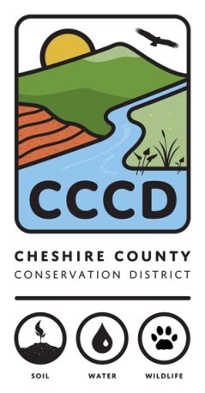
---------------------------------------------------------------------------------------------------------------------------------------
For further information contact: Amanda Littleton at 401-578-1608 or amanda@cheshireconservation.org
The Cheshire County Conservation District is a management partner and fiscal sponsor of the Monadnock Food Co-op Farm Fund. The Cheshire County Conservation District’s mission is to promote the conservation and responsible use of our natural and agricultural resources for the people of Cheshire County by providing technical, financial, and educational assistance.

Our goal is to encourage the stewardship of healthy soils, productive ecologically sound farms, diverse wildlife, productive sustainable forests, healthy watersheds, and clean water to ensure those resources are available for future generations.

