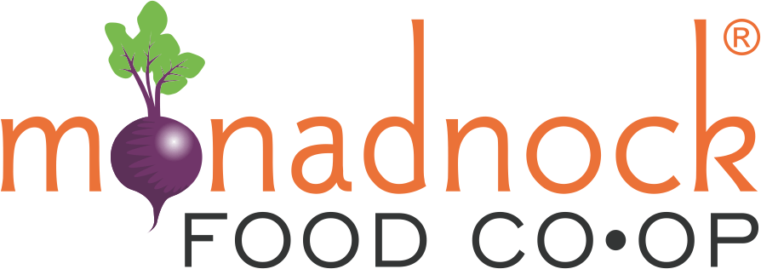
2024 Farm Fund
Request for Proposals

Introduction
The mission of the Monadnock Food Co-op Farm Fund is to support local farmers committed to wholesale production in increasing sustainable food production and the viability of their operations to contribute to a thriving local farm economy.

The Monadnock Food Co-op (MFC) in partnership with the Cheshire County Conservation District (CCCD) request proposals from farms who seek funding to make investments in the following project categories:
- Food safety planning and infrastructure
- Equipment for efficient and sustainable food production and harvesting
- Food storage infrastructure
- Equipment for value-added food production
- Packaging and labeling development, including the design of logos
- Cost share for technical assistance including business and financial planning from the NH Community Loan Fund or other reputable providers
- Critical farm infrastructure and necessary capital improvements for long-term farm viability. This project category is only available for farms who have been established and contributing to the agricultural economy for more than ten years.
- Support for farmland conservation (this could include succession planning and attorney fees associated with the permanent protection of farmland)
NEW IN 2024
- Emergency Relief – relief from the financial strain of crop and/or livestock loss caused by weather events. Please use the Emergency Relief Application Form if seeking support in this category.

The following will not be funded:
- Farm staff time
- Advertising
- Research and feasibility studies
- Efforts that will not lead to increased production and wholesale sales
- Day to day operational costs (e.g. seeds, mulch, fertilizer, etc.)

Priority in the 2024 grant round will be given to Emergency Relief requests. A minimum of 1/3 of funding will be reserved for other project categories. Applications in other project categories will be evaluated by the following criteria:
- Increase farm profitability
- Develop or expand production for wholesale markets, including the Monadnock Food Co-op
- Meet market demand
- Cost/benefit analysis determines efficient use of funds
- Have a significant impact on the long-term viability of the farm. This includes the permanent land protection through conservation and capital improvements for critical farm infrastructure.

Eligible Applicants & Sites
A. Eligible Applicants
Farms in Cheshire County and abutting NH towns.
If applying for Emergency Relief, the eligibility has been expanded to also include agricultural producers in NH and VT that have an established vendor relationship with the Monadnock Food Co-op. Producers with an existing relationship with Monadnock Food Co-op will be prioritized.
Farm businesses in operation for at least one year and have secure access (own, lease) to land on which the operator is farming. If renting, the lease must be in writing, and have a term long enough for the farmer to complete the proposed improvement project and see a return on the investment.
To receive funding a farm must operate in compliance with all applicable federal, state, and local regulations.

B. Eligible Sites
Projects will need the signed consent and approval of the appropriate governing body or landowner(s).

Program Funding and Project Duration
A. Funding Availability
There is approximately $20,000 available in the 2024 funding cycle. Awards no less than $500 and no greater than $20,000 will be considered. Program administrators reserve the right to offer funding to selected projects at an amount less than requested in the application budget. Program administers also reserve the right to deny funding to applicants that do not propose a strong project. Remaining funding, if any, will be made available in future grant rounds.

Program participants must provide receipts verifying expenditures have occurred within the contract period prior to receiving grant funds. Costs incurred prior to contract execution cannot be reimbursed and will not qualify as Program expenditures.

B. Project Timeframe
Project must be completed and final report submitted by December 31, 2024.

C. Timeframe: Grant Award Funding Decisions and Allocations
Process | Approximate Time Frame
1. RFP is available. | October 1, 2023
2. Proposals for Emergency Relief are due. | October 31, 2023
3. Proposals in other project categories are due. | February 1, 2024
4. Proposal review process. Applicants may be contacted for additional information to clarify the project. | February 1-28, 2024
5. All Applicants are notified of funding decision. | March 15, 2024
6. Project ends and report and photos are due. | December 31, 2024

No payment will be made for project costs incurred prior to notification of grant award.

Application Submittal Procedure
The proposal can be submitted digitally or by hard copy in the mail. Applications must be postmarked by the due date.

- Proposals Mailed to:
Monadnock Food Co-op Farm Fund
Cheshire County Conservation District
11 Industrial Park Dr
Walpole NH 03608
Or email to:
Amanda@cheshireconservation.org

Proposal Due Date: October 31, 2023 for Emergency Relief & February 1, 2024 for other project categories

Grant Funding and Information Required for Funded Applications

Successful Applicants – Grantees - will be required to submit the following additional information:

Alternate W-9 (form provided by CCCD).

Certificate of Insurance, with the “Monadnock Community Market Cooperative, Inc.” and “Cheshire County Conservation District” listed as an additional insured. Comprehensive public liability insurance in amounts not less than $1,000,000 for bodily injury or death and $500,000 for property damage, statutory workers' compensation and employees' liability insurance are required. Cost of insurance cannot be a component of the application. The CCCD may choose to modify this requirement after evaluating the possible exposure of the CCCD to liability with respect to the proposed grant agreement.

Signed contract (provided by CCCD)

Contracts of subcontractors if applicable.

Project Monitoring

Payment for the project will be made upon the completion of the project and submission of final report. 25-50% of project costs can be made available at the start of the project upon request with reasonable justification.

Grantees are required to submit a final project report in a digital format. A template will be provided. The final project report shall document the completion of project tasks and the results attained, include documentation of all expenses, contain before and after photos, as jpg files, of the project as applicable, and share a testimonial from the farm owner and/or manager on the benefits the financial assistance from the Farm Fund provided.

For Further Information
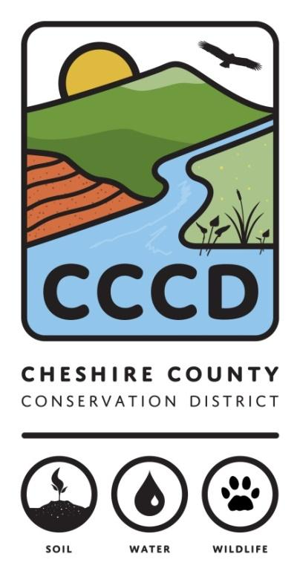
For further information, and to discuss project ideas contact: Amanda Littleton at 401-578-1608 or amanda@cheshireconservation.org
The Cheshire County Conservation District is a management partner and fiscal sponsor of the Monadnock Food Co-op Farm Fund.

The Cheshire County Conservation District’s mission is to promote the conservation and responsible use of our natural and agricultural resources for the people of Cheshire County by providing technical, financial, and educational assistance. Our goal is to encourage the stewardship of healthy soils, productive ecologically sound farms, diverse wildlife, productive sustainable forests, healthy watersheds, and clean water to ensure those resources are available for future generations.

