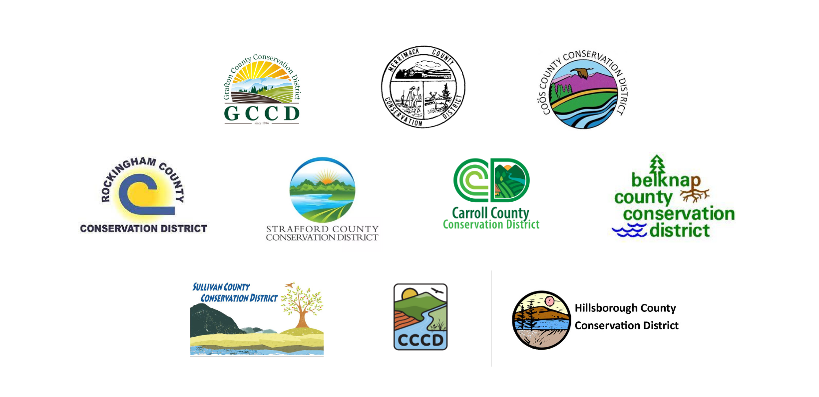
2026 NH Conservation Districts Climate Resilience Grant Application

If you are filling out the application by hand, please make sure it is legible!

PROJECT OVERVIEW

Project Title: _____________________ Amount Requested: _________________

Total Budget: ___________________ Project Location: _____________________

APPLICANT INFORMATION

Applicant Name (First and Last): ___________________________________________
Applicant Farm: _______________________________________________________
Email: ________________________ Phone Number: __________________________

Have you ever applied to the NH Conservation Districts Climate Resilience Grant? ☐ Yes ☐ No
If yes, was your application successful? ☐ Yes ☐ No

Are you a limited resource farmer, beginning farmer, socially disadvantaged farm, and/or veteran farmer as defined by the USDA (view definitions here). If yes, please indicate below which USDA categories are applicable to you?
☐ Socially disadvantaged
☐ Low income
☐ Beginning farmer (started in last 10 years)
☐ Veteran farmer
Farm Location (Street Address, Town, State, and County): ____________________________________________________________________________________________________________________________________________________________

Year Your Business Started: ____________________

Briefly Describe Your Product(s) or Service(s): ________________________________________ ____________________________________________________________________________________________________________________________________________________________

How did you hear about this opportunity? __________________________________________
______________________________________________________________________________
______________________________________________________________________________

PROJECT INFORMATION

Please select a project focus area. If your project has more than one focus area, select all that apply:
☐ Soil Health
☐ Energy
☐ Water Management
☐ Crop and Livestock Protection – Integrated pest management and/or solutions for livestock heat stress

Please identify which metric(s) you will track during the grant period and report on in your final report. A minimum of one metric must be selected for a project to be eligible for funding. Please use one of the metrics below or provide your own metric if needed. Select all the metrics applicable to your project. If you are uncertain of the best metric for your project, please consult your technical service provider for their recommendation. If your project has multiple focus areas, please select trackable metrics for each focus area.

METRIC LIST

SOIL HEALTH PROJECTS
☐ Soil organic matter is anticipated to increase. Organic matter will be tested at the start of the project and at the conclusion of the project. Test results will be submitted in the final report.
☐ Anticipated reduction in tillage. Tillage will be tracked and reported based on a comparison of the prior year’s tillage regime.
☐ Anticipated increase/reduction of inputs (compost, fertilizer, herbicides, etc.) Inputs will be tracked and reported based on a comparison of the prior year’s inputs.
☐ Other, please specify: ____________________________________________________________
______________________________________________________________________________________

ENERGY PROJECTS
☐ Electricity usage is expected to decrease. Electricity usage (kilowatt-hour (kWh)) will be tracked and reported on through monthly electric bills in the final report.
☐ Renewable energy production will increase. Monthly generation (kilowatt-hour (kWh)) will be tracked and reported on in the final report.
☐ Other, please specify: ____________________________________________________________
______________________________________________________________________________________

WATER MANAGEMENT PROJECTS
☐ Water usage is expected to decrease or be managed more efficiently. Water usage numbers before and after the project implementation will be tracked and shared in the final report.
☐ Other, please specify: ____________________________________________________________
______________________________________________________________________________________

CROP PROTECTION AND LIVESTOCK WELLBEING PROJECTS
☐ Pest damage is expected to decrease. Crop scouting and crop production numbers before and after the project implementation will be tracked and shared in the final report.
☐ Livestock wellbeing is expected to improve. For projects focused on heat stress, temperature readings (in barns and shade areas) will be tracked and shared in the final report.
☐ Other, please specify: ____________________________________________________________
______________________________________________________________________________________
AGRICULTURAL SERVICE PROVIDERS
Farms are encouraged to work with an Agricultural Service Provider (e.g. UNH Cooperative Extension Educator, Crop Advisor, USDA NRCS Conservation Planner, NHACD Planner, etc.,) as a Technical Advisor on project planning and implementation. If you are working with an Agricultural Service Provider for technical assistance on your project, please have them complete a Partnership Form and submit it with your application.

If you are not working with an Agricultural Service Provider, please share your plan on how you will effectively complete your proposed project in the questions below. Please outline the expertise and experience needed and who you will be working with to provide it.

If you are not working with a service provider and would like to, please contact your County Conservation District for a referral and they will connect you with one.

PROJECT DESCRIPTION

Please answer the following questions (1-13) in 1,000-2,500 words total in this question format. Please do not use a separate narrative and include as much detail as possible when answering each question.

- Please describe your project.

- What are the project’s goals?

- What are the tasks and timeline of the project?

- How will this project improve your farm’s ability to mitigate or adapt to climate change?

- How will this project benefit your farm?

- Please describe the capacity of your farm to complete the project. Who will be responsible? Please use names and relevant experience where applicable.

- What technical assistance do you anticipate needing to ensure that this project is successful?

- Will you be willing to work with your Conservation District to make the public aware of the project (e.g. press, social media, community events, hosting a farm tour, etc.)? Please explain your level of interest.

- How will you educate other farmers on the benefit of the project?

- What is your plan for covering ongoing costs after the grant is completed? What is your plan to ensure the sustainability of your project?

- How/when will you know you’re successful? What metrics and targets will you use?

- Have you applied for funding from USDA NRCS for this project? Please explain why or why not?

- If you applied to NRCS, was this project selected for funding? If yes, please explain why you need additional funding to move the project forward. If not, please indicate here.

PROJECT BUDGET

- Amount Requested ($100 - $10,000):

- How much money is needed in total to complete the proposed project?

- If your farm receives funding, how do you plan to pay for remaining expenses? Please explain the source and status of the other funds (e.g. are they secured?)

REMINDER - Farms are responsible for a minimum of 25% of project costs. This can include in-kind time and equipment use of the farm and should be tracked. Please use the rates listed in the In-Kind Contribution Tracking Form. This form should be used to track time if awarded a grant.

Please summarize your project costs on the table below. Include any costs covered by the farm applicant, costs requested from the grant fund, and funds contributed from other sources. Indicate in the designated column which expenses the applicant will cover, which expenses will be covered by other sources (if any), and which expenses you request from the grant fund.

Please include vendor quotes when applicable to help demonstrate the accuracy of your budget.

Allowable expenses: Practice implementation costs, materials costs, architectural, land planning, and/or engineering services, other direct expenses, equipment (all equipment purchased through grant funds must be new and under product warranty), technical assistance, consultant and legal services

Expenses not allowed: Advertising, research and feasibility studies, efforts that will not lead to increased climate resiliency, and experimental projects. Farm staff time and/or equipment use can be used as a match but is not an allowed expense for the grant funds.

BUDGET TABLE
In the table below, please provide an itemized budget and references. In the budget justification section, please provide a detailed overview of your budget (for example, rather than writing “supplies,” provide a detailed justification of anticipated supplies and estimated cost).
Budget Item |  |  |  | Total Amount |  | Grant Request | Applicant Costs | Other  (ex. NRCS funding)
Supplies
Contractors
Other
TOTAL EXPENSES
Please provide a budget justification narrative:

REQUIRED ATTACHMENTS

All applicants must include the following attachments:
- A map (topographic or aerial) with the project location identified (maps can be retrieved through Google Maps)
- A preliminary design or plan (as applicable)
- A quote or estimate from a contractor or vendor (as applicable)
- Clear photos of the project site
- If your farm has employees that will be involved in the project, statutory workers’ compensation and employees’ liability insurance are required

Further questions and/or references may be requested upon committee review.

Thank you!
By submitting this application, if approved, you give permission to the NH Conservation Districts to announce the grant award through area media sources and publicize your organization as a recipient of the New Hampshire Conservation Districts Climate Resilience Grant in promotional material.

Grants are expected to be used for their stated purpose by the end of the grant period; if necessary, grantees may request an extension of the grant period or return unused funds.

Please submit your application and application related inquiries directly to your respective county.

The proposal can be submitted digitally (preferred) or by hard copy in the mail to County Conservation District staff. Applications must be postmarked by the due date. Handwritten applications should be in clear and legible writing.

A. Proposals Mailed to:

Digital applications should be submitted in the following format:

Please include: “Climate Resilience Grant Application” in the email subject line.

All application material file attachments must be named: Applicant First Name_Applicant Last Name_ClimateGrant” (Example: Jane_Smith_ClimateGrant), if there are multiple attachments, 5 please include a brief description in the file name such as: Jane_Smith_ClimateGrantApplication or Jane_Smith_ClimateGrantMap

County contact information can be found here!

