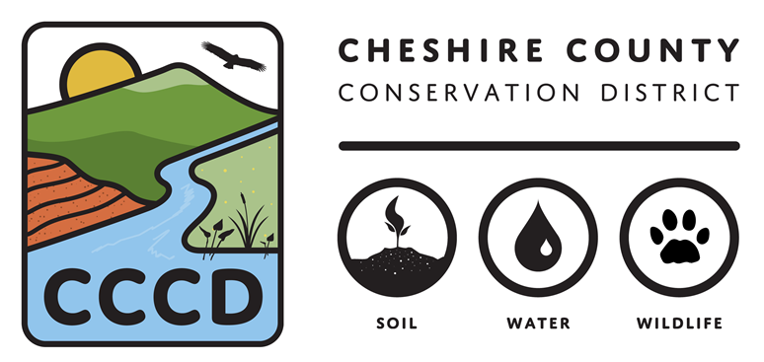
2026 CONSERVATION OPPPORTUNITY FUND
Application Form
Before completing this application, please carefully review the Request for Proposals (RFP), which is available at www.cheshireconservation.org/cof
Applicants must answer all questions fully to be considered for funding. Applicants must use the application form, or it will not be considered for funding.
Please only submit an application if you check YES to all the following criteria:

PRIMARY CRITERIA | NO YES
You are a qualified applicant – a landowner or steward of less than 25 acres  in Cheshire County, NH that is interested in improving the wildlife habitat on  their property | ☐ ☐
Your project includes community outreach, engagement, and/or education | ☐ ☐
The project activities are listed in the eligible activities list in the RFP  or have been pre-approved by the Conservation District. | ☐ ☐
The project will be completed, and all the grant funds will be spent, by  December 31st of the year of the grant award. | ☐ ☐
The project has not been started and will not begin until it is selected for  funding and there is a site visit with the Conservation District to review  plans and provide advice for the successful completion of the project. | ☐ ☐
APPLICANT INFORMATION

Applicant Name: ______________________________________________________
Mailing Address: ______________________________________________________
___________________________________________________________________
Contact Person: _______________________________________________________
Email: ________________________ Phone Number: __________________________

PROJECT INFORMATION
Project Type:
☐ Installation of native pollinator habitat
☐ Installation of rain garden
☐ Creation/maintenance of early successional habitat
☐ Creation of vegetation buffer on surface water
☐ Conversion of lawns and/or fields to native plant gardens
☐ Other approved project, please specify: _________________________________________
______________________________________________________________________________________
Project Location: ____________________________________________________________________________
Grant Amount Requested: ___________________________________________________________________
Size of Project (acres or sq ft): _______________________________________________________________

PROJECT NARRATIVE
1,000 word maximum – the narrative must address the following items. Please answer questions directly and in the order laid out below.

- Please briefly describe your project.

- What are the expected outcomes of your project?

- What are the activities/tasks you will complete to reach your outcomes? Please provide details on the anticipated site preparation that will be necessary for any planting projects.

- The Conservation District is here to provide technical assistance to ensure the success of your project. What guidance would be most helpful to you?

- Please briefly describe what skills and resources (e.g. long-time gardener, water sources for planting success, etc.) you have to successfully complete this project?

- What is your plan for long-term maintenance and sustainability of your project?

- What education are you interested in doing as part of this project? (e.g. offering workshops in partnership with CCCD, writing a blog post for CCCD newsletter/website, offering content for CCCD social media, etc.)

- Describe how you would like your project to involve community engagement. In what ways can CCCD help support you in these goals?

- Did you attend the online information session or speak with staff in advance of submitting your application?

- How did you find out about this program? (CCCD newsletter, social media, newspaper, neighbor, etc.)

BUDGET TABLE AND BUDGET JUSTIFICATION NARRATIVE
Please summarize your anticipated project costs in the table below. The total requested budget cannot exceed $1,500. Allowable expenses include plant and site preparation materials. Landowner’s hour expenses are not allowed.
Budget Item |  |  |  | Total Amount | Description/Justification of Budget Item
TOTAL EXPENSES

What time do you anticipate committing to this project? Do you anticipate any other funds being contributed to this project? Please briefly explain.

FINAL SUBMISSION INFORMATION
Applicants should submit the following items in support of their application:
☐ Project Application – including narrative and budget
☐ Project Map – please include one hand drawn or digitally composed map of where your project will be installed
☐ Photos – one or two photos of the project site as it currently is (jpgs)

Completed applications must be received no later than 5 p.m. on February 1, 2026.
EMAIL: Applications may be submitted electronically to info@cheshireconservation.org. Please include “Conservation Opportunity Fund Application” in the email subject line.
MAIL: Applications can also be sent by mail and must be postmarked no later than February 1. Mail applications to: Conservation Opportunity Fund, Cheshire County Conservation District, 11 Industrial Park Dr, Walpole NH 03608.
All application material file attachments must be named: Applicant First Name_Applicant Last Name_COF” (Example: Jane_Smith_COF), if there are multiple attachments, please include a brief description in the file name such as: Jane_Smith_COFApplication or Jane_Smith_COFMap

All grant applicants will be notified of selection results in early March 2026.
Further questions and/or references may be requested upon committee review.
By submitting this application, if approved, you give the Cheshire County Conservation District permission to announce the grant award through area media sources and publicize you or your organization as a recipient of a Conservation Opportunity Fund grant in promotional material. Access to the application and supporting materials will be provided to the review committee.

